Accredited by NAAC, Accredited by NBA, Approved by AICTE, Affiliated to JNTUA, Anantapuram & Recognized by UGC under 2(f) & 12(B)
Yerrakota, Yemmiganur-518360, Kurnool (Dt.), A.P.

VISION
To be a preferred technical institution from rural background to contribute towards the advancement of community, region and nation as a whole and to elevate the students into technically strong and ethically sound individuals.

MISSION
- Engage all the stake holders and utilize the infrastructure to develop technically sound employable human resources to translate our vision into a reality.
- Providing quality education in this region.
- Creating curiosity and innovative thinking among the students.

PROGRAMOUTCOMES(POS)
- Engineering knowledge: Apply the knowledge of mathematics, science, engineering fundamentals, and an engineering specialization to the solution of complex engineering problems.
- Problem analysis: Identify, formulate, review research literature, and analyze complex engineering problems reaching substantiated conclusions using first principles of mathematics, natural sciences, and engineering sciences.
- Design/development of solutions: Design solutions for complex engineering problems and design system components or processes that meet the specified needs with appropriate consideration for the public health and safety, and the cultural, societal, and environmental considerations
- Conduct investigations of complex problems: Use research-based knowledge and research methods including design of experiments, analysis and interpretation of data, and synthesis of the information to provide valid conclusions.
- Modern tool usage: Create, select, and apply appropriate techniques, resources, and modern engineering and IT tools including prediction and modeling to complex engineering activities with an understanding of the limitations.
- The engineer and society: Apply reasoning informed by the contextual knowledge to assess societal, health, safety, legal and cultural issues and the consequent responsibilities relevant to the professional engineering practice.
- Environment and sustainability: Understand the impact of the professional engineering solutions in societal and environmental contexts, and demonstrate the knowledge of, and need for sustainable development.
- Ethics: Apply ethical principles and commit to professional ethics and responsibilities and norms of the engineering practice.
- Individual and team work: Function effectively as an individual, and as a member or leader in diverse teams, and in multidisciplinary settings.
- Communication: Communicate effectively on complex engineering activities with the engineering community and with society at large, such as, being able to comprehend and write effective reports and design documentation, make effective presentations, and give and receive clear instructions.
- Project management and finance: Demonstrate knowledge and understanding of the engineering and management principles and apply these to one's own work, as a member and leader in a team, to manage projects and in multidisciplinary environments.
- Life-long learning: Recognize the need for, and have the preparation and ability to engage in independent and lifelong learning in the broadest context of technological change.
• To impart technical education to the rural students and making them employable in the respective domain.
- Up gradation of laboratories with state of the art equipment as the right tools of pedagogy for better lesson delivery
- Providing bridge classes for average and slow learners.
- Arranging interactive sessions with industries and thereby enhance the practical knowledge and technical skills of the student.

PROGRAMSPECIFICOUTCOMES(PSOs)
- Analyses and design of electronic circuits and Communication systems for multi-disciplinary tasks.
- Should have an ability to apply technical knowledge and usage of modern hardware and software tools related to Electronics & Communication engineering for solving real world problems.

PROGRAMEDUCATIONALOBJECTIVES(PEOs)
- Graduates will be able to stimulate continuing education with their existing knowledge in the field of Electronics and Communication Engineering.
- Prepare graduates to practice their profession with ethics, integrity, and social responsibility in a global context.
- Participate in lifelong learning activities to continue their professional development.

 | PO1 | PO2 | PO3 | PO4 | PO5 | PO6 | PO7 | PO8 | PO9 | PO10 | PO11 | PO12
CO1
CO2
CO3
CO4
CO5

ACKNOWLEDGEMENT
At the very outset we would like to take this opportunity to express our gratitude to almighty for his blessings showered upon us to complete this project work. We are deeply indebted to our parents and family members for their unconditional love and support. They have been on our side during high and low phases of the project.
We wish to thank our Project Guide Madam Dr K. SUVARNA, M.Tech.,(Ph.D) Associate. Professor, St.Johns College of Engineering & Technology, for his incessant guidance, encouragement and patience in not only our project work, but also in our overall academic and professional career. His constant enthusiasm and genuine interest in our academic progress and project work has been a great source of moral support all along and also we thank for his immense insight into the analysis of our project work.
We are deeply indebted to the Project coordinator, Sri S.AHMED BASHA, M.Tech.,(Ph.D) Asst. Professor, St.John’s College of Engineering & Technology, for his generous guidance, help and useful suggestions, without which it would have been impossible.
We are very much thankful to Dr. K.SUVARNA, M.Tech.,(PhD)., HOD, St.Johns College of Engineering & Technology, for providing us the infrastructural facilities to work in and giving us an opportunity to complete our project work.
We would like to thank Dr. K.SUDHAKAR M.Tech., (Ph.D), Principal, St.Johns College of Engineering & Technology, for his valuable advices and guidance. We would also like to express our gratitude to the Faculty of Department of Electronics & Communication Engineering, St. Johns College of Engineering & Technology, Yerrakota, for their constant support.
We are also thankful to all our friends for their immense help in completion of this project.
Batch-13
A. Naresh - 22G31A0402
D. Vinay Kumar - 22G31A0415
G. Gopal - 22G31A0431
S K. Khalandar - 22G31A0442

Face Detection based Attendance system using ESP32 Embedded and Python
A Project Report Submitted in Partial fulfillment of the requirements
For the award of degree of
BACHELOR OF TECHNOLOGY
In
ELECTRONICS AND COMMUNICATION ENGINEERING
Of
JAWAHARLAL NEHRU TECHNOLOGICAL UNIVERSITY, ANANTHAPURAMU
By
Aarav
Under the Esteemed Guidance of
Dr. KAKANI SUVARNA ME,Ph.D,MIE,
Associate Professor
Department of Electronics and Communication Engineering
St. JOHNS COLLEGE OFENGINEERING & TECHNOLOGY
YERRAKOTA, YEMMIGANUR
KURNOOL – 518 360 (A.P)
2025-2026
1

St. JOHNS COLLEGE OFENGINEERING & TECHNOLOGY
YERRAKOTA, YEMMIGANUR
KURNOOL – 518 360, (A.P)
(Permanently Affiliated to J.N.T.U.A)
DEPARTMENT OF ELECTRONICS AND COMMUNICATION ENGINEERING
CERTIFICATE
This is to certify that Project report entitled being submitted by

in partial
fulfillment of the requirement of the award of the degree of Bachelor of Technology in
Electronics and Communication Engineering of Jawaharlal Nehru Technological University, Ananthapuram during the year 2025-2026.
Dr. KAKANI SUVARNA _{ME, Ph. D, MIE},
Dr K. SUVARNA, M.Tech.,Ph.D
Associate ProfessorAssociate Professor & HOD
Project GuideDept. of E.C.E
Dept. of E.C.ES.J.C.E.T S.J.C.E.T
Place:
Date:
Certified thatthecandidate wasexaminedbymeintheviva-voce Examination held at St.Johns College of Engineering & Technology, Yemmiganur on
INTERNAL EXAMINEREXTERNAL EXAMINER
CONTENTS
Project Title: Face Detection based Attendance System using ESP32 Embedded and Python
CHAPTER – 1: INTRODUCTION 1 - 8
1.1 Introduction
1.2 Existing Method
1.3 Proposed Method
1.4 Literature Review
1.4.1 Automated Attendance System
1.4.2 IoT Based Attendance System
1.4.3 Deep Learning Attendance System
1.4.4 Embedded Vision System
1.4.5 Haar Cascade Method
1.4.6 Digital Image Processing
1.4.7 ESP32 Reference
1.4.8 OpenCV Documentation
1.5 Block Diagram
CHAPTER – 2: HARDWARE DESCRIPTION 10 - 37
2.1 ESP32 Microcontroller
2.1.1 Dual Core Processor
2.1.2 Internal Memory
2.1.3 External Flash & SRAM
2.1.4 Wi-Fi
2.1.5 Bluetooth
2.1.6 Features
2.1.7 GPIO & Sensors
2.1.8 Applications
2.2 GSM Module
2.2.1 TDMA
2.2.2 GSM Architecture
2.2.3 Frequency Bands
2.2.4 Call Flow
2.2.5 Security
2.2.6 Applications
2.3 Web Camera
2.3.1 Working
2.3.2 Components
2.3.3 Sensors
2.3.4 Resolution
2.4 I2C LCD
2.4.1 16x2 LCD
2.4.2 20x4 LCD
2.4.3 Working
2.4.4 Applications
2.5 Buzzer
2.5.1 Pin Configuration
2.5.2 Features
2.5.3 Applications

CHAPTER – 3: SOFTWARE IMPLEMENTATION 38 - 60
3.1 Software Components
3.1.1 Python .
3.1.2 Features
3.1.3 History
3.1.4 Versions
3.1.5 Applications
3.1.6 Dataset Code
3.1.7 Python Attendance Code
3.2 Embedded C
3.2.1 Features
3.2.2 Structure
3.2.3 KEIL IDE
3.2.4 Memory
3.2.5 Interrupts
3.3 Arduino IDE
3.3.1 ESP32 Code
3.3.2 Advantages

CHAPTER – 4: RESULTS 61 - 62
4.1 Student Attendance Sheet
4.2 Captured Images
CHAPTER – 5: CONCLUSION 63 - 65
5.1 Conclusion
5.2 Future Scope
5.3 References

LIST OF FIGURES

Figure No Figure Title Page No
Fig 1.5 Face Detection Block Diagram 9
Fig 2.1 ESP32 Microcontroller 10
Fig 2.1.3a External Flash & SRAM 13
Fig 2.1.3b Memory Mapping 14
Fig 2.1.9 ESP32 Pinout 18
Fig 2.2.1e GSM Architecture 21
Fig 2.3 Web Camera 26
Fig 2.4 I2C LCD 31

CHAPTER – 1
INTRODUCTION

Chapter – 1

Introduction
1.1 In modern educational environments, maintaining accurate attendance records is essential for monitoring student performance and discipline. Conventional attendance systems require manual effort, consume valuable class time, and allow fraudulent practices such as proxy attendance. To overcome these limitations, biometric-based attendance systems have gained significant attention. Among various biometric techniques, face recognition is non-intrusive, fast, and user-friendly. This project integrates ESP32 microcontroller, Python-based face recognition, GSM communication, and Excel-based data storage to create a smart attendance system. The ESP32 acts as the embedded controller handling alerts, LCD display, and buzzer activation. Python performs face detection, training, and recognition using real-time video captured by a USB camera. Attendance records are automatically stored, and absence notifications are sent to parents, making the system reliable, secure, and scalable.
1.2ExistingMethod:
Traditional attendance systems primarily rely on manual methods, such as paper-based registers or biometric devices like fingerprint scanners. These systems often suffer from limitations including time consumption, human error, proxy attendance, and limited security. Fingerprint or card-based systems can be easily bypassed, and administrators are required to manually manage records, which can be inefficient for large organizations. Furthermore, existing automated solutions may lack real-time remote notification and integration capabilities, limiting their effectiveness in modern environments.
1.3ProposedMethod:
The proposed Face Detection-Based Attendance System using ESP32 overcomes the limitations of traditional systems by integrating real-time face recognition with embedded control. A USB web camera captures images of individuals, which are processed using Python-based algorithms to identify registered personnel accurately. The ESP32 microcontroller manages the system, interfacing with an I2C LCD to display attendance status, while a buzzer alerts when unregistered individuals are detected. Additionally, the GSM module enables remote notifications, allowing administrators to receive attendance records instantly. Powered by a reliable 12V adapter and securely connected, this prototype enhances accuracy, reduces human error, prevents unauthorized attendance, and provides a scalable solution for modern institutions.

1.4 Literature Reviews:
1.4.1 Automated Attendance System Using Face Recognition
Matter:
This work presents an automated attendance system based on face recognition technology. Facial images are captured through a camera and processed using image processing techniques such as Haar Cascade classifiers to detect and recognize individuals. Attendance is recorded automatically in a database, reducing manual intervention and improving accuracy. However, the system lacks real-time alert mechanisms and embedded system integration for enhanced security.
1.4.2 Smart Attendance Monitoring System Using IoT and Face Detection
This system integrates face detection with IoT technology to provide automated attendance monitoring. A camera module captures facial images, and attendance records are stored in a cloud database for remote access. The system enables online monitoring but depends heavily on continuous internet connectivity and does not include security alerts for unauthorized individuals.
1.4.3 Real-Time Face Recognition Attendance System Using Deep Learning
This approach employs deep learning-based face recognition using convolutional neural networks for real-time attendance tracking. Live video frames are processed to identify registered individuals with high accuracy, even under varying lighting conditions. Despite improved recognition performance, the system requires high computational resources and is not suitable for low-cost embedded hardware.
1.4.4 Embedded Vision-Based Attendance System with Security Alert Mechanism
This model implements an embedded vision system for automated attendance. Face detection is performed using OpenCV algorithms, and attendance information is displayed on an LCD interface. A security alert mechanism is included to detect unknown individuals. However, the system does not support GSM-based remote notifications or large-scale database integration.
1.4.5 Rapid Object Detection Using a Boosted Cascade of Simple FeaturesThis research introduced the Haar Cascade method for fast and efficient object detection, particularly face detection. The technique uses boosted cascade classifiers to detect faces realtime with low computational complexity. It serves as a foundational method for many face recognition-based attendance systems.in realtime with low computational complexity. It serves as a foundational method for many face recognition-based attendance systems.

1.4.6 Digital Image Processing

This reference explains fundamental image processing concepts including image enhancement, segmentation, feature extraction, and pattern recognition. These techniques form the theoretical foundation for facial recognition and image analysis in automated attendance systems.

1.4.7 ESP32 Technical Reference Manual
This document provides detailed technical information about the ESP32 microcontroller, including its architecture, communication protocols, and peripheral interfacing. It is essential for implementing embedded control, LCD interfacing, and GSM communication in attendance management systems.

1.4.8 OpenCV Documentation – Face Recognition and Image Processing

OpenCV provides open-source libraries for real-time image processing and computer vision. The documentation includes tools for face detection and recognition that are widely used in developing automated attendance systems with high processing efficiency.

1.5 Block diagram:
Power supply

Esp32 microcontroller
usb web camera
i2c lcd
buzzer
gsm

Fig 1.5: Face Detection based Attendance System using ESP32 Embedded and Python

CHAPTER II DESCRIPTION
AND SPECIFICATIONS OF
THE HARDWARE MODULE IMPLEMENTATION.

Chapter – 02

DESCRIPTION AND SPECIFICATION OF THE HARDWARE MOUDLE IMPLEMENTATION
2. Hardware Components:
- ESP32 MICROCONTROLLER
- GSM
- BUZZERS
- 5V POWER SUPPLY
- 12V 1A ADAPATERS
- USB WEB CAMERA
- i2c lcd

2.1 ESP32 Microcontroller:
ESP32 is a low-cost, low-power Microcontroller with an integrated Wi-Fi and Bluetooth. It is the successor to the ESP8266 which is also a low-cost Wi-Fi microchip albeit with limited vastly limited functionality.
It is an integrated antenna and RF balun, power amplifier, low-noise amplifiers, filters, and power management module. The entire solution takes up the least amount of printed circuit board area. This board is used with 2.4 GHz dual-mode Wi-Fi and Bluetooth chips by TSMC 40nm low power technology, power and RF properties best, which is safe, reliable, and scale-able to a variety of applications.
The block diagram below shows all that is in there! We will look at each of these blocks and see what they mean when using ESP32 in your project.
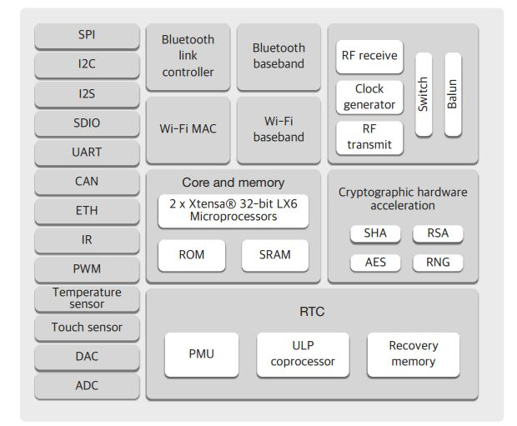

Fig 2.1: ESP32 Microcontroller

2.1.1 The Dual Core Processor:
The predecessor of ESP32, the ESP8266 has a builtin processor. However due to multitasking involved in updating the WiFi stack, most of the applications use a separate micro-controller for data processing, interfacing sensors and digital Input Output. With the ESP32 you may not want to use an additional micro-controller. ESP32 has Xtensa® Dual-Core 32-bit LX6 microprocessors, which runs up to 600 DMIPS. The ESP32 will run on breakout boards and modules from 160Mhz upto 240MHz . That is very good speed for anything that requires a microcontroller with connectivity options.
The two cores are named Protocol CPU (PRO_CPU) and Application CPU (APP_CPU). That basically means the PRO_CPU processor handles the WiFi, Bluetooth and other internal peripherals like SPI, I2C, ADC etc. The APP_CPU is left out for the application code. This differentiation is done in the Espressif Internet Development Framework (ESP-IDF). ESP-IDF is the official software development framework for the chip. Arduino and other implementations for the development will be based on ESP-IDF.
ESP-IDF uses freeRTOS for switching between the processors and data exchange between them. We have done numerous tutorials on freeRTOS and with all the bare-metal programming tutorials for ESP32 we will try and cover this aspect in detail. Although the feature set is great at the price at which the chip is being sold, the complexity is enormous. For the chip to get widely adopted, it will require huge efforts from Espressif as well as the community.

2.1.2 Internal Memory
The processors have closely tied internal memory for the following usage:
- 448 KBytes ROM for booting and core functions.
- 520 KBytes on-chip SRAM for data and instruction.
- 8 KBytes SRAM in RTC, which is called RTC SLOW Memory and can be accessed by the co-processor
- during the Deep-sleep mode.
- 8 KBytes SRAM in RTC, which is called RTC FAST Memory and can be used for data storage; it is accessed
- by the main CPU during RTC Boot from the Deep-sleep mode.
- 1 Kbit of EFUSE, of which 256 bits are used for the system (MAC address and chip configuration) and the remaining 768 bits are reserved for customer applications, including Flash-Encryption and Chip-ID
2.1.3 External Flash and SRAM
Most of the modules like ESP32 Wroom use external Flash-W25Q32 (4M Bytes!) for storing the application code. The chip supports 4 x 16 MBytes of external QSPI flash and SRAM with hardware encryption based on AES.
- ESP32 accesses the external QSPI flash and SRAM through high-speed caches.
- Up to 16 MBytes of external flash are memory-mapped onto the CPU code space, supporting 8, 16 and 32-bit access. Code execution is supported.
- Up to 8 MBytes of external SRAM are memory-mapped onto the CPU data space, supporting 8, 16 and 32-bit access. Data-read is supported on the flash and SRAM. Data-write is supported on the SRAM.
Since the processor architecture is 32 bit. The internal peripherals, the wifi, Bluetooth, External Memories etc are mapped to 2^32 (4GB) address space.
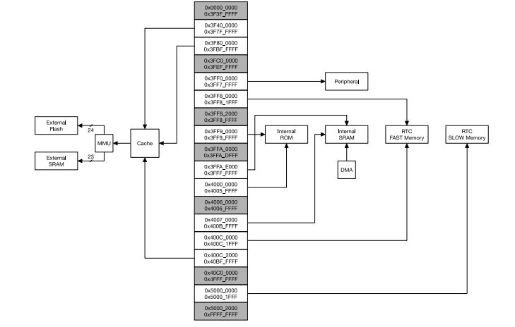
Fig 2.1.3a: External Flash and SRAM
Also, one interesting thing to note is that the both processors are mapped symmetrically to this address space. It basically means, a register for example can be accessed from same address location from both the CPUs as shown in image below.
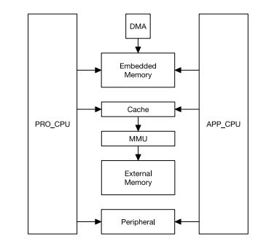
Fig 2.1.3b: External Flash and SRAM

2.1.4 The WiFi
ESP32 implements TCP/IP, full 802.11 b/g/n/e/i WLAN MAC protocol, and Wi-Fi Direct specification. This means ESP 32 can speak to most of the WiFi Routers out there when used in station(client) mode. Also it is able to create an Access point with full 802.11 b/g/n/e/i.
ESP32 also supports the Wi-Fi Direct . Wifi-Direct is good option for peer-to-peer connection without the need of a access point. The Wifi-Direct is easier to setup and the data transfer speeds are much better than bluetooth. This could potential be used to configure ESP32 based projects from a phone/tablet that supports WiFi direct. There is no code example in the ESP-IDF SDK at the time of the writing. The ESP-IDF WiFi implementation has following features in the development:
- Infrastructure BSS Station mode / P2P mode / softAP mode support
- P2P Discovery, P2P Group Owner, P2P Group Client and P2P Power Management
- WPA/WPA2-Enterprise and WPS driver
- Additional 802.11i security features such as pre-authentication and TSN
- Open interface for various upper layer authentication schemes over EAP such as TLS, PEAP, LEAP, SIM, AKA or customer specific
- Clock/power gating combined with 802.11-compliant power management dynamically adapted to current connection condition providing minimal power consumption
- Adaptive rate fallback algorithm sets the optimal transmission rate and transmit power based on actual Signal Noise Ratio (SNR) and packet loss information
- Automatic re-transmission and response on MAC to avoid packet discarding on slow host environment
2.1.5 Bluetooth Classic and Bluetooth Low Energy (BLE)
ESP32 not just supports the latest BLE Bluetooth 4.2, it also supports classic bluetooth. It basically means it can speak to old and new bluetooth phones/tables. This could one of the best features especially, if you're designing a device that needs to work with existing as well as new phones/tablets in the market. The ESP32 Bluetooth Radio and Baseband supports the following features:
- Class-1, class-2 and class-3 transmit output powers and over 30 dB dynamic control range
- π/4 DQPSK and 8 DPSK modulation
- High performance in NZIF receiver sensitivity with over 98 dB dynamic range
- Class-1 operation without external PA
- Internal SRAM allows full speed data transfer, mixed voice and data, and full piconet operation
- Logic for forward error correction, header error control, access code correlation, CRC, demodulation, encryption bit stream generation, whitening and transmit pulse shaping
- ACL, SCO, eSCO and AFH
- A-law, µ-law and CVSD digital audio CODEC in PCM interface
- SBC audio CODEC
- Power management for low power applications
- SMP with 128-bit AE

2.1.6 Classic Bluetooth Link Controller Features
- Device Discovery (inquiry and inquiry scan)
- Connection establishment (page and page scan)
- Multi connections
- Asynchronous data reception and transmission
- Synchronous links (SCO/eSCO)
- Master/Slave Switch
- Adaptive Frequency Hopping and Channel assessment
- Broadcast encryption
- Authentication and encryption
- Secure Simple Pairing
- Multi-point and scatternet management
- Sniff mode
- Connectionless Slave Broadcast (transmitter and receiver)
- Enhanced power control
- Ping

2.1.7 Bluetooth Low Energy Link Controller Features
- Advertising
- Scanning
- Multiple connections
- Asynchronous data reception and transmission
- Adaptive Frequency Hopping and Channel assessment
- Connection parameter update
- Date Length Extension
- Link Layer Encryption
- LE Ping

2.1.8 Built-in Periherals
The built-in features of ESP32 are simply mind-numbing. These are more than any micro-controller that I've ever used till date in a single project. So the features are simply listed below. A lot can be done with these, and these will receive special treatment with numerous tutorials in the days to come.
- Timers and Watchdog
- Real Time Clock
- ADC and built-in Sensors
- Digital to Analog Convertor (DAC)
- Touch Sensor
- Ultra Low Power(ULP) Co-processor
- Ethernet MAC Interface
- SD/SDIO/MMC Host Controller
- Universal Asynchronous Receiver Transmitter (UART)
- I2C Interface
- I2S Interface
- SPI Interface
- Infrared Remote Controller
- Pulse Counter
- Pulse Width Modulation (PWM)
- Hardware Accelerator

2.1.9 Package and Pinout
All the features we have looked so far, all packed in 48 pin QFN package size 6mm x 6mm. [Image here] A better picture to look at is the pinout diagram for the ESP Wroom32 breakout.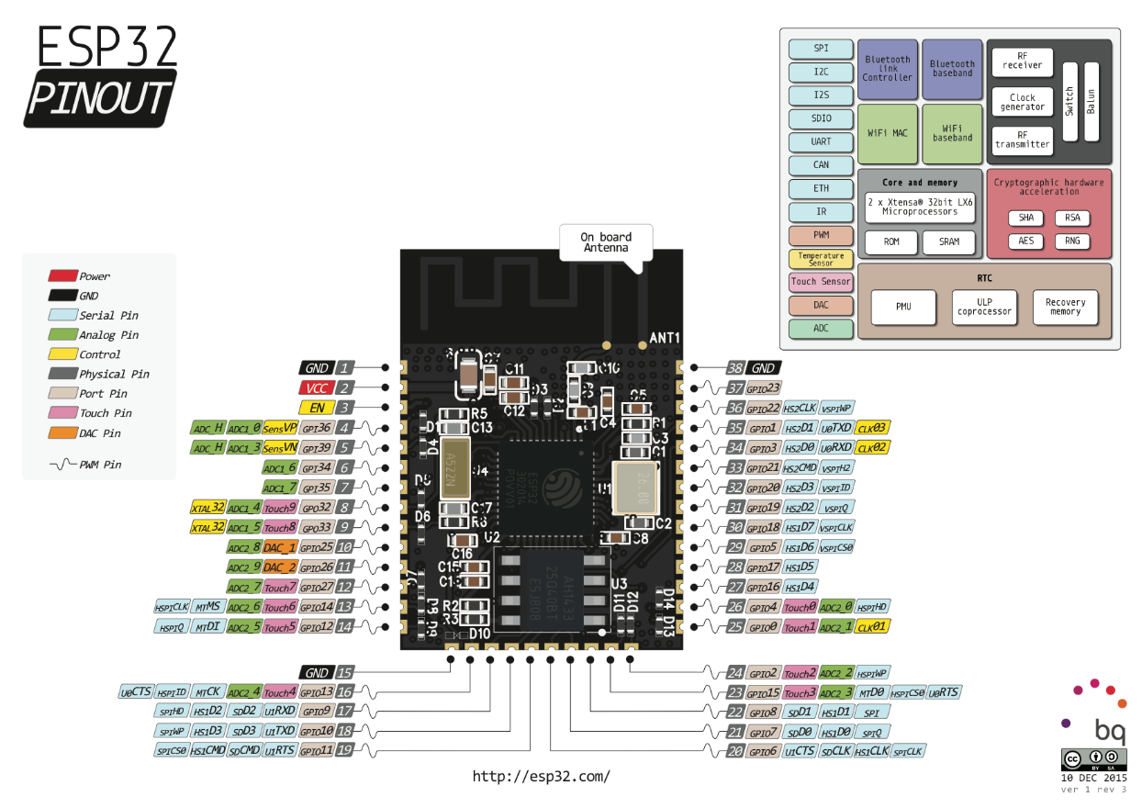
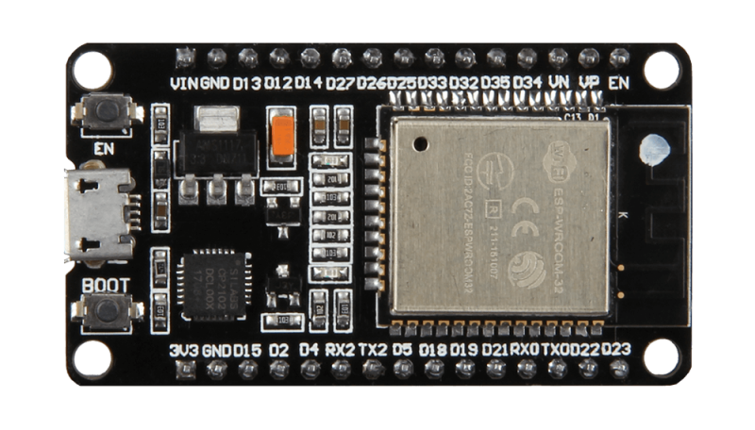

Fig 2.1.9 Package and Pinout

2.1.10 Power Management and Low-Power Modes
One of the most important advantages of ESP32 is its advanced power-saving capability, making it ideal for battery-powered and IoT applications. ESP32 provides multiple operating modes to reduce energy consumption depending on system requirements.

a. Power Modes of ESP32
- Active Mode – CPU, Wi-Fi, and Bluetooth are fully operational.
- Modem Sleep Mode – CPU runs while Wi-Fi/Bluetooth are temporarily disabled.
- Light Sleep Mode – CPU pauses execution while memory and peripherals remain active.
- Deep Sleep Mode – Only RTC memory and ULP co-processor remain active.
- Hibernation Mode – Minimum power consumption; most components powered off.
In deep sleep mode, ESP32 consumes only a few microamps, which significantly increases battery life in IoT devices such as environmental monitoring systems and wearable electronics.

Security Features
ESP32 provides strong hardware-level security features, making it suitable for secure IoT and industrial applications.

a. Key Security Capabilities
- Secure Boot to prevent unauthorized firmware execution
- Flash Encryption using AES-256
- Hardware random number generator (RNG)
- Cryptographic accelerators for:
  - AES
  - SHA-2
  - RSA
  - ECC
- Secure firmware updates (OTA security)
These features protect devices from hacking, cloning, and firmware tampering.

Over-The-Air (OTA) Firmware Updates
ESP32 supports OTA (Over-The-Air) updates, allowing firmware upgrades through Wi-Fi without physical access to the device.

a. Advantages of OTA:
- Remote bug fixing
- Feature upgrades after deployment
- Reduced maintenance cost
- Easy large-scale device management
OTA is widely used in smart home devices, industrial automation, and remote monitoring systems.

GPIO Capabilities
ESP32 provides highly flexible General Purpose Input Output (GPIO) pins compared to traditional microcontrollers.

a. GPIO Features
- Up to 34 programmable GPIO pins
- Interrupt support on most pins
- Input and output functionality
- Internal pull-up and pull-down resistors
- PWM generation on multiple pins
- Capacitive touch sensing capability
The GPIO matrix allows almost any peripheral signal to be routed to any GPIO pin, increasing hardware design flexibility.

Analog Features and Sensors
ESP32 includes built-in analog components that reduce the need for external hardware.

a. Analog Components
- 12-bit ADC (Analog-to-Digital Converter)
- 2 channels of 8-bit DAC
- Hall effect sensor (magnetic field detection)
- Internal temperature sensing capability (approximate measurement)
These features allow ESP32 to interface directly with sensors like temperature, gas, and light sensors.

Development Environment Support
ESP32 supports multiple development platforms, making it beginner-friendly as well as professional-grade.

Supported Development Platforms
- Arduino IDE
- ESP-IDF (Official Framework)
- PlatformIO
- MicroPython
- CircuitPython
This flexibility enables developers to program ESP32 using C, C++, or Python depending on application needs.

Applications of ESP32
Due to its powerful processing and wireless connectivity, ESP32 is widely used in various domains.

a. Common Applications
- Internet of Things (IoT) systems
- Smart home automation
- Wireless sensor networks
- Industrial monitoring
- Wearable devices
- Smart agriculture
- Health monitoring systems
- Robotics and automation
- Smart energy meters
- GPS tracking systems

Advantages of ESP32
- Low cost with high performance
- Integrated Wi-Fi and Bluetooth
- Dual-core processing capability
- Large number of peripherals
- Low power consumption
- Strong security features
- OTA firmware update support
- Large developer community support

14. Limitations of ESP32
- Higher power consumption than simple microcontrollers (like Arduino UNO)
- ADC accuracy slightly lower compared to dedicated ADC chips
- Complex architecture for beginners using ESP-IDF
- Some GPIO pins have boot restrictions

Future Scope of ESP32
ESP32 continues to evolve with newer variants such as ESP32-S2, ESP32-S3, and ESP32-C3, offering improved AI acceleration, USB support, and enhanced security. These advancements make ESP32 suitable for edge AI, smart vision systems, and next-generation IoT applications.
2.2 GSM
GSM is a mobile communication modem; it is stands for global system for mobile communication (GSM). The idea of GSM was developed at Bell Laboratories in 1970. It is widely used mobile communication system in the world. GSM is an open and digital cellular technology used for transmitting mobile voice and data services operates at the 850MHz, 900MHz, 1800MHz and 1900MHz frequency bands.
GSM system was developed as a digital system using time division multiple access (TDMA) technique for communication purpose. A GSM digitizes and reduces the data, then sends it down through a channel with two different streams of client data, each in its own particular time slot. The digital system has an ability to carry 64 kbps to 120 Mbps of data rates.
There are various cell sizes in a GSM system such as macro, micro, pico and umbrella cells. Each cell varies as per the implementation domain. There are five different cell sizes in a GSM network macro, micro, pico and umbrella cells. The coverage area of each cell varies according to the implementation environment.

2.2.1a Time Division Multiple Access
TDMA technique relies on assigning different time slots to each user on the same frequency. It can easily adapt to data transmission and voice communication and can carry 64kbps to 120Mbps of data rate.

2.2.1b GSM Architecture
A GSM network consists of the following components:
- A Mobile Station: It is the mobile phone which consists of the transceiver, the display and the processor and is controlled by a SIM card operating over the network.
- Base Station Subsystem: It acts as an interface between the mobile station and the network subsystem. It consists of the Base Transceiver Station which contains the radio transceivers and handles the protocols for communication with mobiles. It also consists of the Base Station Controller which controls the Base Transceiver station and acts as a interface between the mobile station and mobile switching centre.
- Network Subsystem: It provides the basic network connection to the mobile stations. The basic part of the Network Subsystem is the Mobile Service Switching Centre which provides access to different networks like ISDN, PSTN etc. It also consists of the Home Location Register and the Visitor Location Register which provides the call routing and roaming capabilities of GSM. It also contains the Equipment Identity Register which maintains an account of all the mobile equipments wherein each mobile is identified by its own IMEI number. IMEI stands for International Mobile Equipment Identity.

2.2.1c Features of GSM Module:
- Improved spectrum efficiency
- International roaming
- Compatibility with integrated services digital network (ISDN)
- Support for new services.
- SIM phonebook management
- Fixed dialing number (FDN)
- Real time clock with alarm management
- High-quality speech
- Uses encryption to make phone calls more secure
- Short message service (SMS)
The security strategies standardized for the GSM system make it the most secure telecommunications standard currently accessible. Although the confidentiality of a call and secrecy of the GSM subscriber is just ensured on the radio channel, this is a major step in achieving end-to- end security.

2.2.1d GSM Modem
A GSM modem is a device which can be either a mobile phone or a modem device which can be used to make a computer or any other processor communicate over a network. A GSM modem requires a SIM card to be operated and operates over a network range subscribed by the network operator. It can be connected to a computer through serial, USB or Bluetooth connection.
A GSM modem can also be a standard GSM mobile phone with the appropriate cable and software driver to connect to a serial port or USB port on your computer. GSM modem is usually preferable to a GSM mobile phone. The GSM modem has wide range of applications in transaction terminals, supply chain management, security applications, weather stations and GPRS mode remote data logging.
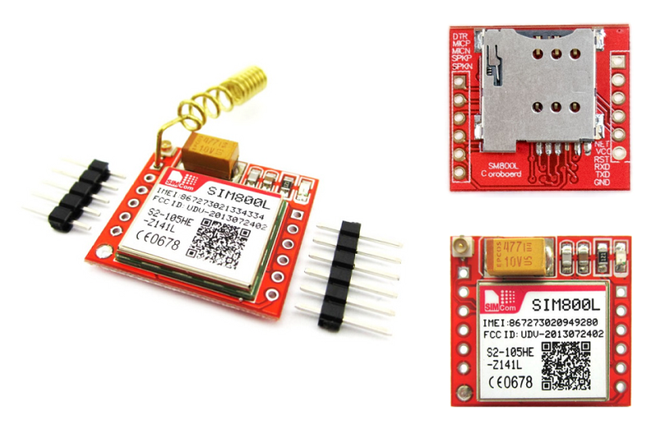
It requires a SIM (Subscriber Identity Module) card just like mobile phones to activate communication with the network. Also they have IMEI (International Mobile Equipment Identity) number similar to mobile phones for their identification. A GSM/GPRS MODEM can perform the following operations:
- Receive, send or delete SMS messages in a SIM.
- Read, add, search phonebook entries of the SIM.
- Make, Receive, or reject a voice call.

The MODEM needs AT commands, for interacting with processor or controller, which are communicated through serial communication. These commands are sent by the controller/processor. The MODEM sends back a result after it receives a command. Different AT commands supported by the MODEM can be sent by the processor/controller/computer to interact with the GSM and GPRS cellular network.

2.2.1e GSM Architecture
The GSM architecture is divided into Radio Subsystem, Network and Switching Subsystem and the Operation Subsystem. The radio sub system consists of the Mobile Station and Base Station Subsystem.
The mobile station is generally the mobile phone which consists of a transceiver, display and a processor. Each handheld or portable mobile station consists of a unique identity stored in a module known as SIM (Subscriber Identity Chip). It is a small microchip which is inserted in the mobile phone and contains the database regarding the mobile station.
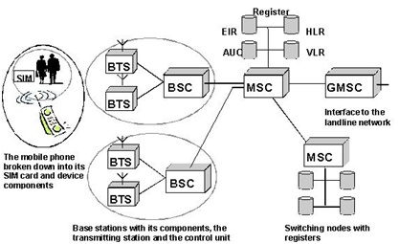

Fig 2.2.1e: GSM Architecture

2.2.2 GSM Frequency Bands and Channels
GSM communication operates in different frequency bands depending on geographical regions. These frequency bands allow multiple users to communicate simultaneously without interference.

2.2.2a Common GSM Frequency Bands
- GSM-850 MHz – Used mainly in North America
- GSM-900 MHz – Widely used in Asia and Europe
- GSM-1800 MHz (DCS) – High-capacity urban areas
- GSM-1900 MHz (PCS) – Used in North America
Each frequency band is divided into multiple channels using TDMA, allowing several users to share the same spectrum efficiently.

2.2.3 GSM Frame Structure
GSM uses a structured timing system to organize communication between mobile devices and base stations.

2.2.3a GSM Frame Hierarchy
- Time Slot – Smallest unit (577 µs)
- Frame – Contains 8 time slots
- Multiframe – Group of frames for signaling and traffic
- Superframe – Combination of multiframes
- Hyperframe – Largest structure used for encryption synchronization
This hierarchical structure ensures synchronized communication and efficient bandwidth utilization.

2.2.4 GSM Call Flow Process
When a user makes a call using GSM, several steps occur automatically within milliseconds.

2.2.4a Call Establishment Steps
- Mobile station sends request to Base Transceiver Station (BTS).
- BTS forwards request to Base Station Controller (BSC).
- BSC sends request to Mobile Switching Centre (MSC).
- MSC verifies subscriber details using HLR/VLR databases.
- Channel allocation is performed.
- Connection is established between caller and receiver.
This process enables reliable voice communication across networks.

2.2.5 GSM Security Mechanisms
GSM incorporates multiple layers of security to protect communication and user identity.

2.2.5a Security Techniques
- Authentication – Verifies SIM card legitimacy.
- Encryption – Protects data transmission over radio channels.
- Temporary Mobile Subscriber Identity (TMSI) – Hides real subscriber identity.
- A3 Algorithm – Authentication algorithm.
- A5 Algorithm – Encryption algorithm.
- A8 Algorithm – Cipher key generation.
These mechanisms prevent unauthorized access and eavesdropping.

2.2.6 GSM Data Services
Apart from voice communication, GSM supports several data transmission services.

2.2.6a Data Services Provided by GSM
- Short Message Service (SMS)
- Multimedia Messaging Service (MMS)
- Circuit Switched Data (CSD)
- General Packet Radio Service (GPRS)
- Enhanced Data Rates for GSM Evolution (EDGE)
GPRS and EDGE improved GSM networks by enabling internet connectivity and higher data speeds.

2.2.7 Advantages of GSM Technology
- Global standard with wide coverage
- High voice clarity due to digital transmission
- Secure communication using encryption
- International roaming capability
- Efficient spectrum utilization
- Supports both voice and data services
- Low operational and maintenance cost

2.2.8 Limitations of GSM
- Limited data speed compared to 3G/4G/5G technologies
- Network congestion in dense areas
- Higher latency for internet applications
- Requires SIM-based authentication
- Power consumption higher than modern IoT communication protocols

2.2.9 Applications of GSM Technology
GSM technology is widely used beyond mobile phones in embedded and IoT systems.

2.2.9a Common Applications
- Vehicle tracking systems
- Smart energy meters
- Remote monitoring systems
- Home security and alarm systems
- Industrial automation
- Weather monitoring stations
- Agricultural monitoring systems
- ATM and POS terminals

2.2.9b GSM in Embedded Systems
In embedded applications, GSM modules are interfaced with microcontrollers such as Arduino, ESP32, or ARM controllers using UART serial communication.

2.2.9c Embedded GSM Functions
- Sending alert SMS messages
- Remote device control
- Sensor data transmission
- Emergency notification systems
- IoT cloud communication
The controller communicates with the GSM module using AT commands to perform operations like sending SMS or establishing internet connections.

2.2.9d Future Evolution of GSM
Although newer technologies like LTE and 5G are widely used, GSM still remains important due to its reliability and extensive infrastructure.
Future trends include:
- GSM integration with IoT devices
- Machine-to-Machine (M2M) communication
- Smart city infrastructure
- Low-cost remote monitoring solutions
Many IoT devices still rely on GSM networks because of their wide coverage and stability.
2.3 WEB CAMERA
A webcam is a video camera those feeds or streams an image or video in real time to or through a computer network, such as the Internet. Webcams are typically small cameras that sit on a desk, attach to a user's monitor, or are built into the hardware. Webcams can be used during a video chat session involving two or more people, with conversations that include live audio and video.
Webcam software enables users to record a video or stream the video on the Internet. As video streaming over the Internet requires much bandwidth, such streams usually use compressed formats. The maximum resolution of a webcam is also lower than most handheld video cameras, as higher resolutions would be reduced during transmission. The lower resolution enables webcams to be relatively inexpensive compared to most video cameras, but the effect is adequate for video chat sessions
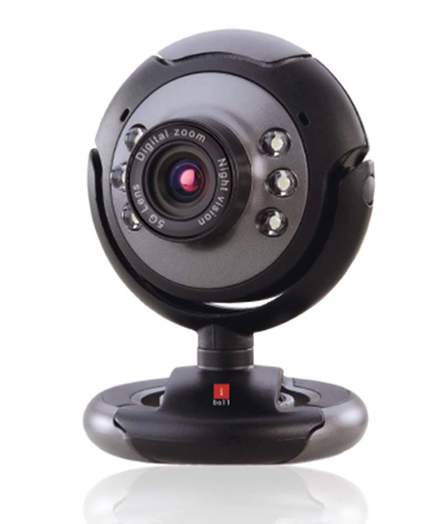
Fig 2.3: WEB CAMERA
A webcam captures light through a lens and converts it into digital signals using an image sensor. The captured images are processed and transmitted to a computer or network in real time.

2.3.1 Basic Working Steps
- Light from an object enters through the webcam lens.
- The image sensor (CMOS/CCD) converts light into electrical signals.
- The signals are converted into digital data.
- Image processing compresses the video using codecs.
- The compressed video is transmitted via USB or wireless network.
- The receiving device displays the live video stream.
This real-time processing allows webcams to support video conferencing and live monitoring applications.

2.3.2 Components of a Webcam
A typical webcam consists of several internal components working together.

2.3.2a Main Components
- Lens – Focuses light onto the image sensor.
- Image Sensor – Converts optical image into electronic signals.
- Processor (DSP) – Processes image data.
- Microphone – Captures audio signals.
- USB Interface – Transfers data to computer.
- LED Indicator – Shows camera activity status.
- Housing and Mount – Supports attachment to monitor or surface.

2.3.3 Types of Image Sensors
Webcams mainly use two types of sensors:

CMOS (Complementary Metal-Oxide Semiconductor)
- Low power consumption
- Low cost
- Common in modern webcams
- Faster image processing

CCD (Charge Coupled Device)
- Better image quality
- Higher sensitivity to light
- More expensive
- Higher power consumption
Most modern webcams use CMOS sensors due to efficiency and affordability.

2.3.4 Webcam Resolution and Frame Rate
The performance of a webcam is determined by resolution and frame rate.

Common Resolutions
- 640 × 480 (VGA)
- 1280 × 720 (HD)
- 1920 × 1080 (Full HD)
- 4K Ultra HD

Frame Rate
- 15 fps – Basic video
- 30 fps – Standard video conferencing
- 60 fps – Smooth motion recording
Higher resolution and frame rates require more bandwidth and processing power.

2.3.5 Video Compression Techniques
To reduce bandwidth usage, webcams use compression algorithms.

Common Video Codecs
- MJPEG (Motion JPEG)
- H.264
- H.265 (HEVC)
- VP8 / VP9
Compression reduces file size while maintaining acceptable video quality during streaming.

2.3.6 Connectivity Interfaces
Webcams connect to devices using different communication methods.
- USB Webcam – Most common type
- Wireless Webcam – Uses Wi-Fi connection
- IP Webcam – Streams directly over internet network
- Built-in Webcam – Integrated in laptops and smart devices
USB webcams typically use plug-and-play functionality supported by operating systems.

2.3.7 Applications of Webcams
Webcams are widely used in multiple domains.

Common Applications
- Video conferencing and online meetings
- Online education and virtual classrooms
- Live streaming and content creation
- Security surveillance systems
- Facial recognition systems
- Telemedicine and remote healthcare
- Robotics and computer vision projects
- Smart monitoring systems

2.3.8 Advantages of Webcams
- Low cost compared to professional cameras
- Real-time video communication
- Easy installation and usage
- Portable and compact design
- Supports online collaboration
- Compatible with most operating systems

2.3.9 Limitations of Webcams
- Limited image quality compared to DSLR cameras
- Performance affected by low lighting
- Dependent on internet bandwidth
- Privacy and security risks if hacked

2.3.10 Webcam in Embedded and AI Systems
Webcams are increasingly used with embedded platforms such as Raspberry Pi and ESP-based systems for computer vision applications.

Example Uses
- Object detection
- Gesture recognition
- Face recognition systems
- Autonomous robots
- Smart attendance systems
With machine learning algorithms, webcams enable intelligent visual sensing applications.

2.3.11 Future Scope of Webcam Technology
Modern webcams are evolving with advanced features such as:
- AI-based auto framing
- Background noise suppression
- Facial tracking
- HDR video processing
- Depth sensing cameras
- Integration with augmented and virtual reality systems
These advancements improve communication quality and enable smart automation systems.
2.4 I2C LCD Technology
I2C (Inter-Integrated Circuit) LCD displays are widely used in various electronic projects due to their ease of use and ability to interface with microcontrollers using minimal wiring. The I2C protocol allows multiple devices to communicate over a two-wire interface, significantly reducing the complexity of connections compared to traditional parallel interfaces. I2C LCDs are available in various sizes, with the 16x2 and 20x4 configurations being among the most common. These displays are ideal for projects requiring user interaction, such as data display, system status monitoring, and menu navigation.
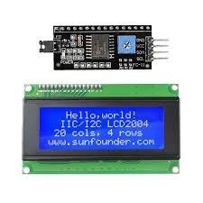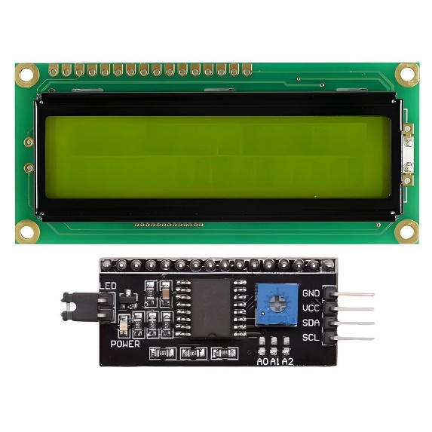
Fig 2.4: I2C LCD Technology
2.4.1 I2C LCD 16x2
The I2C LCD 16x2 consists of 16 columns and 2 rows, allowing for the display of up to 32 characters at a time. Each character is represented in a 5x8 pixel matrix, which provides clear and readable output for various applications. The 16x2 LCD is commonly used in beginner projects, educational settings, and prototypes due to its compact size and straightforward implementation.
This display module is equipped with an I2C interface, which typically includes an I2C controller module (often based on the PCF8574 or similar chip). This module converts the parallel data from the LCD into a serial format suitable for I2C communication. To connect the 16x2 LCD to a microcontroller (such as an Arduino), only four connections are needed: power (VCC), ground (GND), SDA (data line), and SCL (clock line). This simplicity not only minimizes wiring but also streamlines programming, allowing developers to focus more on functionality.
2.4.2 I2C LCD 20x4
The I2C LCD 20x4 is a larger variant, featuring 20 columns and 4 rows, which enables the display of up to 80 characters simultaneously. This increased display area is particularly beneficial for applications requiring more information to be shown at once, such as real-time sensor data, user menus, or status updates. The 20x4 LCD is favored in more advanced projects, where the need for extensive information display is critical.
Similar to the 16x2 model, the I2C 20x4 display utilizes an I2C controller to facilitate communication between the microcontroller and the LCD. The wiring requirements remain the same, with only four connections needed. The additional characters and lines make this display suitable for applications in industrial settings, information kiosks, and any project where detailed data presentation is essential. Users can customize the displayed information, formatting it to enhance readability and user experience.
2.4.3 Advantages of I2C LCDs
Both the I2C LCD 16x2 and 20x4 offer numerous advantages, including ease of installation, reduced wiring complexity, and efficient data transmission. The I2C protocol supports multiple devices on the same bus, allowing for the integration of various sensors and peripherals without extensive wiring. This feature is particularly advantageous in compact projects where space is limited. Furthermore, the libraries available for I2C LCDs in various programming environments, such as Arduino IDE, simplify the coding process, making it accessible even to novice developers.
The backlight feature common in these displays enhances visibility in low-light environments, making them suitable for both indoor and outdoor applications. The ability to control the brightness of the backlight can also contribute to energy efficiency, allowing users to tailor the display’s performance to their specific needs.

2.4.4 Applications
I2C LCDs, both 16x2 and 20x4, find applications in various fields, including robotics, automation, data logging, and home automation systems. They are frequently used in projects such as temperature and humidity monitoring, real-time data display for IoT devices, and user interface menus for embedded systems. Their versatility and functionality make them a preferred choice among hobbyists and professionals alike. As technology continues to evolve, the integration of I2C LCDs into more sophisticated systems will likely expand, further enhancing user interaction and data presentation in electronic projects.

2.4.5 Working Principle of I2C LCD Display
An I2C LCD works by converting serial data received through the I2C communication protocol into parallel data required by the LCD controller (usually HD44780). The microcontroller sends commands and character data through the SDA and SCL lines, which are interpreted by the I2C interface module.

Operation Steps
- Microcontroller sends data via I2C protocol.
- I2C controller (PCF8574) receives serial data.
- Serial data is converted into parallel signals.
- LCD controller processes commands or characters.
- Characters are displayed on the LCD screen.
This method greatly reduces the number of GPIO pins required compared to traditional LCD interfacing.

2.4.6 I2C Communication Protocol Overview
I2C (Inter-Integrated Circuit) is a synchronous communication protocol developed for short-distance communication between integrated circuits.

Key Features
- Two-wire communication:
  - SDA (Serial Data Line)
  - SCL (Serial Clock Line)
- Master–Slave architecture
- Supports multiple devices on the same bus
- Each device has a unique address
- Half-duplex communication
The microcontroller acts as the master device, while the LCD operates as a slave device.

2.4.7 I2C Addressing in LCD Modules
Each I2C LCD module has a unique hexadecimal address used for communication.

Common I2C Addresses
- 0x27 (most common)
- 0x3F (alternate address)
The address can be identified using an I2C scanner program. Some modules allow address modification using jumper pads on the I2C backpack.

2.4.8 Pin Description of I2C LCD
The I2C LCD module requires only four pins:
Pin | Function
VCC | Power supply (5V or 3.3V)
GND | Ground connection
SDA | Serial data communication
SCL | Clock signal
This reduced pin requirement allows easy integration with microcontrollers like Arduino, ESP32, and Raspberry Pi.

2.4.9 LCD Command and Data Modes
The LCD operates in two primary modes:

Command Mode
Used to send instructions such as:
- Clear display
- Set cursor position
- Display ON/OFF
- Cursor blinking control

Data Mode
Used to send ASCII characters that appear on the screen.
The I2C interface automatically manages switching between these modes.

2.4.10 Backlight Control and Contrast Adjustment
Most I2C LCD modules include:
- Backlight LED control
- Contrast adjustment potentiometer

Benefits
- Improves visibility under different lighting conditions
- Allows power saving by disabling backlight when not required
- Enhances readability for long-term display usage

2.4.11 Interfacing I2C LCD with Microcontrollers
I2C LCDs are compatible with many embedded platforms:

Supported Controllers
- Arduino UNO / Mega / Nano
- ESP32
- ESP8266
- Raspberry Pi
- ARM Cortex microcontrollers
Libraries such as LiquidCrystal_I2C simplify communication by providing ready-made display functions.

2.4.12 Advantages Over Parallel LCD Interface
Feature | Parallel LCD | I2C LCD
Pins Required | 6–12 pins | Only 2 pins
Wiring Complexity | High | Low
Expandability | Limited | High
Suitable for IoT | Moderate | Excellent
I2C LCDs are especially useful when GPIO pins are limited.

2.4.13 Troubleshooting Common Issues

Common Problems and Solutions
- Blank screen → Adjust contrast potentiometer.
- Wrong characters → Check I2C address.
- No display → Verify SDA and SCL connections.
- Flickering display → Ensure stable power supply.
Proper wiring and address configuration solve most issues.

2.4.14 Power Consumption
I2C LCD displays consume relatively low power.
Typical consumption:
- Logic circuit: ~1–2 mA
- Backlight: 15–25 mA
Backlight control helps reduce total power usage in battery-powered applications.

2.4.15 Future Scope of I2C LCD Displays
I2C LCD technology continues to be used in modern embedded systems due to simplicity and reliability. Future improvements include:
- Integration with IoT dashboards
- Smart user interfaces
- Low-power display modules
- Hybrid LCD-OLED replacements
- AI-based embedded monitoring systems
2.5 Buzzer:
A buzzer or beeper is an audio signaling device, which may be mechanical, electromechanical, or piezoelectric. Typical uses of buzzers and beepers include alarm devices, timers and confirmation of user input such as a mouse click or keystroke. Buzzer is an integrated structure of electronic transducers, DC power supply, widely used in computers, printers, copiers, alarms, electronic toys, automotive electronic equipment, telephones, timers and other electronic products for sound devices. Active buzzer 5V Rated power can be directly connected to a continuous sound, this section dedicated sensor expansion module and the board in combination, can complete a simple circuit design, to "plug and play.
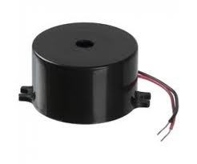

2.5.1 Buzzer Pin Configuration
Pin Number | Pin Name | Description
1 | Positive | Identified by (+) symbol or longer terminal lead. Can be powered by 5V DC
2 | Negative | Identified by short terminal lead. Typically connected to the ground of the circuit

2.5.2 Buzzer Features and Specifications
- Rated Voltage: 6V DC
- Operating Voltage: 4-8V DC
- Rated current: <30mA
- Sound Type: Continuous Beep
- Resonant Frequency: ~2300 Hz
- Small and neat sealed package
- Breadboard and Perf board friendly
2.5.3 How to use a Buzzer
A buzzer is a small yet efficient component to add sound features to our project/system. It is very small and compact 2-pin structure hence can be easily used on breadboard, Perf Board and even on PCBs which makes this a widely used component in most electronic applications.
There are two types are buzzers that are commonly available. The one shown here is a simple buzzer which when powered will make a Continuous Beweep.... sound, the other type is called a readymade buzzer which will look bulkier than this and will produce a Beep. Beep. Beep. Sound due to the internal oscillating circuit present inside it. But, the one shown here is most widely used because it can be customized with help of other circuits to fit easily in our application.
This buzzer can be used by simply powering it using a DC power supply ranging from 4V to 9V. A simple 9V battery can also be used, but it is recommended to use a regulated +5V or +6V DC supply. The buzzer is normally associated with a switching circuit to turn ON or turn OFF the buzzer at required time and require interval.
2.5.4 Applications of Buzzer
- Alarming Circuits, where the user has to be alarmed about something
- Communication equipment’s
- Automobile electronics
- Portable equipment’s, due to its compact size

CHAPTHER – III
SOFTWARE IMPLEMENTATION

Chapter – 03
Software Implementation
3.1 Software components:
- Arduino Ide
- Embedded C
- Python
3.1.1 PYTHON:

Python is a general purpose, dynamic, high level and interpreted programming language. It supports Object Oriented programming approach to develop applications. It is simple and easy to learn and provides lots of high-level data structures. It is easy to learn yet powerful and versatile scripting language which makes it attractive for Application Development. It's syntax and dynamic typing with its interpreted nature, makes it an ideal language for scripting and rapid application development. It supports multiple programming patterns, including object oriented, imperative and functional or procedural programming styles. It is not intended to work on special area such as web programming. That is why it is known as multipurpose because it can be used with web, enterprise, 3D CAD etc. We don't need to use data types to declare variable because it is dynamically typed so we can write a=10 to assign an integer value in an integer variable.It makes the development and debugging fast because there is no compilation step included in python development and edit-test-debug cycle is very fast.

3.1.2 Python Features
Python provides lots of features that are listed below.

1) Easy to Learn and Use
Python is easy to learn and use. It is developer-friendly and high level programming language.

2) Expressive Language
Python language is more expressive means that it is more understandable and readable.

3) Interpreted Language
Python is an interpreted language i.e. interpreter executes the code line by line at a time. This makes debugging easy and thus suitable for beginners.

4) Cross-platform Language
Python can run equally on different platforms such as Windows, Linux, Unix and Macintosh etc. So, we can say that Python is a portable language.

5) Free and Open Source
Python language is freely available at address. The source-code is also available. Therefore it is open source.

6) Object-Oriented Language
Python supports object oriented language and concepts of classes and objects come into existence.

7) Extensible
It implies that other languages such as C/C++ can be used to compile the code and thus it can be used further in our python code.

8) Large Standard Library
Python has a large and broad library and provides rich set of module and functions for rapid application development.

9) GUI Programming Support

Graphical user interfaces can be developed using Python.

10) Integrated
It can be easily integrated with languages like C, C++, JAVA etc.

3.1.3 Python History
- Python laid its foundation in the late 1980s.
- The implementation of Python was started in the December 1989 by Guido Van Rossum at CWI in Netherland.
- In February 1991, van Rossum published the code (labeled version 0.9.0) to alt.sources.
- In 1994, Python 1.0 was released with new features like: lambda, map, filter, and reduce.
- Python 2.0 added new features like: list comprehensions, garbage collection system.
- On December 3, 2008, Python 3.0 (also called "Py3K") was released. It was designed to rectify fundamental flaw of the language.
- ABC programming language is said to be the predecessor of Python language which was capable of Exception Handling and interfacing with Amoeba Operating System.
- Python is influenced by following programming languages:
  - ABC language.
  - Modula-3
3.1.4 Python Version
Python programming language is being updated regularly with new features and supports. There are lots of updations in python versions, started from 1994 to current release.
A list of python versions with its released date is given below.
Python Version Released Date
Python 1.0 January 1994
Python 1.5 December 31, 1997
Python 1.6 September 5, 2000
Python 2.0 October 16, 2000
Python 2.1 April 17, 2001
Python 2.2 December 21, 2001
Python 2.3 July 29, 2003
Python 2.4 November 30, 2004
Python 2.5 September 19, 2006
Python 2.6 October 1, 2008
Python 2.7 July 3, 2010
Python 3.0 December 3, 2008
Python 3.1 June 27, 2009
Python 3.2 February 20, 2011
Python 3.3 September 29, 2012
Python 3.4 March 16, 2014
Python 3.5 September 13, 2015
Python 3.6 December 23, 2016
Python 3.6.4 December 19, 2017

3.1.5 Python Applications Area
Python is known for its general purpose nature that makes it applicable in almost each domain of software development. Python as a whole can be used in any sphere of development.
Here, we are specifying applications areas where python can be applied.

1) Web Applications
We can use Python to develop web applications. It provides libraries to handle internet protocols such as HTML and XML, JSON, Email processing, request, beautifulSoup, Feedparser etc. It also provides Frameworks such as Django, Pyramid, Flask etc to design and delelop web based applications. Some important developments are: PythonWikiEngines, Pocoo, PythonBlogSoftware etc.

2) Desktop GUI Applications
Python provides Tk GUI library to develop user interface in python based application. Some other useful toolkits widgets, Kivy, pyqt that are useable on several platforms. The Kivy is popular for writing multitouch applications.

3) Software Development
Python is helpful for software development process. It works as a support language and can be used for build control and management, testing etc.

4) Scientific and Numeric
Python is popular and widely used in scientific and numeric computing. Some useful library and package are SciPy, Pandas, I Python etc. SciPy is group of packages of engineering, science and mathematics.

5) Business Applications
Python is used to build Bussiness applications like ERP and e-commerce systems. Tryton is a high level application platform.

6) Console Based Application
We can use Python to develop console based applications. For example: I Python.

7) Audio or Video based Applications
Python is awesome to perform multiple tasks and can be used to develop multimedia applications. Some of real applications are: Tim Player, clay etc.

8) 3D CAD Applications
To create CAD application Fandango is a real application which provides full features of CAD.

9) Enterprise Applications
Python can be used to create applications which can be used within an Enterprise or an Organization. Some real time applications are: OpenErp, Tryton, Picalo etc.

10) Applications for Images

Using Python several application can be developed for image. Applications developed are: VPython, Gogh, imgSeek etc. There are several such applications which can be developed using Python.

3.1.6 DATASET CODE:-
import cv2
import os
import pandas as pd

harcascadePath = cv2.data.haarcascades + "haarcascade_frontalface_default.xml"
detector = cv2.CascadeClassifier(harcascadePath)

if detector.empty():
print("[ERROR] Could not load Haar Cascade XML.")
exit()

cam = cv2.VideoCapture(0)
if not cam.isOpened():
print("[ERROR] Could not access the camera.")
exit()

# ====== INPUT DETAILS ======
name = input('\nEnter your Name: ')
roll_number = input('Enter your Roll Number: ')
face_id = input('Enter user ID (numeric): ')

print("\n[INFO] Initializing face capture. Look at camera...")

count = 0
os.makedirs("dataset", exist_ok=True)

# ====== CREATE STUDENT DATABASE FILE ======
student_file = "students.xlsx"

if not os.path.exists(student_file):
df = pd.DataFrame(columns=["ID", "Name", "Roll"])
df.to_excel(student_file, index=False)

df = pd.read_excel(student_file)

# Prevent duplicate ID
if int(face_id) in df["ID"].values:
print("ID already exists!")
else:
new_row = {"ID": int(face_id), "Name": name, "Roll": roll_number}
df = pd.concat([df, pd.DataFrame([new_row])], ignore_index=True)
df.to_excel(student_file, index=False)
print("Student details saved.")

# ====== FACE CAPTURE ======
while True:
ret, img = cam.read()
if not ret:
break

gray = cv2.cvtColor(img, cv2.COLOR_BGR2GRAY)
faces = detector.detectMultiScale(gray, 1.3, 5)

for (x, y, w, h) in faces:
cv2.rectangle(img, (x,y), (x+w,y+h), (255,0,0), 2)
count += 1

face_img = gray[y:y+h, x:x+w]
filename = f"dataset/User.{face_id}.{count}.jpg"
cv2.imwrite(filename, face_img)

cv2.imshow('image', img)

if cv2.waitKey(100) & 0xFF == ord('q'):
break
elif count >= 80:
break

print("\n[INFO] Face Capture Completed")
cam.release()
cv2.destroyAllWindows()

3.1.7 PYTHON CODE:-
import cv2
import pandas as pd
import serial
import os
import time
from datetime import datetime

# ================= SERIAL =================
try:
ser = serial.Serial('COM6', 9600, timeout=1)
time.sleep(2)
print("ESP32 Connected")
except:
print("ESP32 Not Connected")
ser = None

# ================= LOAD MODEL =================
recognizer = cv2.face.LBPHFaceRecognizer_create()
recognizer.read("trainer.yml")

faceCascade = cv2.CascadeClassifier(
cv2.data.haarcascades + "haarcascade_frontalface_default.xml"
)

students_df = pd.read_excel("students.xlsx")
attendance_file = "attendance.xlsx"

# ================= CREATE FILE IF NOT EXISTS =================
if not os.path.exists(attendance_file):
df = pd.DataFrame(columns=["ID","Name","Roll","Date","Period","Time"])
df.to_excel(attendance_file, index=False)

# =====================================================
def take_attendance():

period = input("Enter Period (1-6): ")
today = datetime.now().strftime("%Y-%m-%d")

cam = cv2.VideoCapture(0)
if not cam.isOpened():
print("Camera not working!")
return

print("\nAttendance Mode Started (Press Q to Exit)\n")

session_present = set()

while True:

ret, img = cam.read()
if not ret:
break

gray = cv2.cvtColor(img, cv2.COLOR_BGR2GRAY)
faces = faceCascade.detectMultiScale(gray, 1.3, 5)

for (x, y, w, h) in faces:

id, confidence = recognizer.predict(gray[y:y+h, x:x+w])

if confidence < 50:

student = students_df[students_df["ID"] == id]

if not student.empty:

name = student.iloc[0]["Name"]
roll = student.iloc[0]["Roll"]
current_time = datetime.now().strftime("%H:%M:%S")

if id not in session_present:
print(f"{name} is PRESENT")
session_present.add(id)

# 🔹 Send to ESP32 (LCD will show PRESENT)
if ser:
message = f"PRESENT,{id},{name},{period}\n"
ser.write(message.encode())
time.sleep(0.5)

# ===== SAVE TO EXCEL =====
df = pd.read_excel(attendance_file)

already_marked = df[
(df["ID"] == id) &
(df["Date"] == today) &
(df["Period"].astype(str) == str(period))
]

if already_marked.empty:
new_row = {
"ID": id,
"Name": name,
"Roll": roll,
"Date": today,
"Period": period,
"Time": current_time
}

df = pd.concat([df, pd.DataFrame([new_row])], ignore_index=True)
df.to_excel(attendance_file, index=False)

label = name
else:
label = "UNKNOWN"
else:
label = "UNKNOWN"

cv2.rectangle(img, (x, y), (x+w, y+h), (0,255,0), 2)
cv2.putText(img, label, (x, y-10),
cv2.FONT_HERSHEY_SIMPLEX,
1, (255,255,255), 2)

cv2.imshow("Attendance System", img)

if cv2.waitKey(1) & 0xFF == ord('q'):
break

cam.release()
cv2.destroyAllWindows()

# ================= ABSENT CHECK =================
df = pd.read_excel(attendance_file)

present_ids = df[
(df["Date"] == today) &
(df["Period"].astype(str) == str(period))
]["ID"].tolist()

print("\n===== ABSENT STUDENTS =====")

for _, row in students_df.iterrows():

if row["ID"] not in present_ids:

print(f"{row['Name']} is ABSENT")

# 🔹 Send ABSENT to ESP32 (LCD + SMS trigger)
if ser:
message = f"ABSENT,{row['ID']},{row['Name']},{period}\n"
ser.write(message.encode())
time.sleep(2)

print("\nAttendance Mode Closed\n")

# =====================================================
def main():

while True:
print("========= FACE ATTENDANCE SYSTEM =========")
print("1 - Take Attendance")
print("2 - Exit")

choice = input("Enter choice: ")

if choice == '1':
take_attendance()
elif choice == '2':
print("System Closed")
break
else:
print("Invalid choice\n")

main()

3.2 EMBEDDED C

Implanted C makes use of KEIL IDE programming. The framework program written in implanted C can be placed away in Microcontroller. The accompanying is a portion of the actual motives behind composing applications in C as opposed to get collectively. It is much less disturbing and much less tedious to write down in C then amassing. C is less traumatic to trade and refresh. You can utilize code available in capacity libraries. C code is compact to different microcontrollers with subsequent to 0 alteration. Genuine, installed C programming need nonstandard expansions to the C driver with a view to bolster charming components, as an example, settled point range catching, numerous unmistakable reminiscence banks, and fundamental I/O operations.
In 2008, the C Standards Committee prolonged the C data to deal with these problems via giving a normal well known to all executions to purchaser to contains numerous additives not handy in standard C, for example, settled factor wide variety catching, named address spaces, and vital I/O equipment tending to.
Installed C utilize the greater part of the grammar and semantics of wellknown C, e.G., number one() paintings, variable definition, facts type statement, contingent proclamations (if, switch. Case), circles (even as, for), capacities, exhibits and strings, structures and union, piece operations, macros, unions, and so on.

3.2.1 Features of Embedded C Programming
Embedded C is specially designed for programming microcontrollers and embedded systems. It combines the flexibility of the C language with hardware-level control required for embedded applications.

Key Features
- Direct access to hardware registers
- Efficient memory utilization
- Fast execution speed
- Support for interrupt handling
- Bit-level operations for hardware control
- Portability across different microcontrollers
- Real-time system programming capability
Embedded C allows developers to control peripherals such as timers, ADC, UART, SPI, and I2C efficiently.

3.2.2 Structure of an Embedded C Program
An Embedded C program generally follows a structured format for proper execution.

Basic Structure
- Header file inclusion
- Macro definitions
- Global variable declarations
- Main function initialization
- Peripheral configuration
- Infinite loop execution

3.2.3 Role of KEIL IDE in Embedded C
KEIL Integrated Development Environment (IDE) is widely used for developing embedded applications.

Functions of KEIL IDE
- Writing and editing Embedded C programs
- Compiling source code
- Debugging using simulation tools
- Generating HEX file
- Uploading program into microcontroller
KEIL supports various ARM and 8051-based microcontrollers and provides built-in debugging tools.

3.2.4 Embedded C vs Standard C
Feature | Standard C | Embedded C
Purpose | General programming | Hardware control
Memory Access | Limited | Direct register access
Execution | OS dependent | Runs without OS
Hardware Interaction | Indirect | Direct
Real-time Support | Limited | High
Embedded C includes hardware-specific extensions not available in standard C.

3.2.5 Memory Types in Embedded Systems
Embedded C programs must efficiently manage different types of memory.

Memory Categories
- ROM/Flash Memory – Stores program code permanently
- RAM – Stores temporary variables
- EEPROM – Stores non-volatile data
- Register Memory – Fast access hardware registers
Efficient memory handling is critical because embedded systems have limited resources.

3.2.6 Interrupt Handling in Embedded C
Interrupts allow microcontrollers to respond immediately to external or internal events.

Types of Interrupts
- Timer interrupt
- External interrupt
- Serial communication interrupt
- ADC interrupt
Interrupt Service Routines (ISR) are used to handle these events without stopping the main program execution.

3.2.7 Advantages of Embedded C
- Easy to understand compared to Assembly language
- Faster development time
- Reusable code libraries
- Hardware-level programming capability
- Portable between controllers
- Efficient execution

3.2.8 Applications of Embedded C
Embedded C is widely used in many real-world systems:
- Home automation systems
- Automotive electronics
- Industrial automation
- Robotics
- Medical devices
- Consumer electronics
- IoT devices
- Smart energy meters

3.2.9 Embedded C Development Process
The typical workflow for Embedded C development includes:
- Writing source code in KEIL IDE
- Compiling the program
- Debugging errors
- Generating HEX file
- Flashing program into microcontroller
- Testing hardware functionality

3.2.10 Limitations of Embedded C
- Hardware dependent programming
- Requires knowledge of microcontroller architecture
- Limited debugging compared to desktop applications
- Memory constraints must be handled carefully

3.2.11 Future Scope of Embedded C
Embedded C continues to be essential in modern embedded and IoT systems. With the growth of smart devices, automation, and edge computing, Embedded C remains a fundamental programming language for low-level system control and real-time applications.
3.2.12 Embedded systems programming
Installed frameworks writing computer programs is not quite the same as creating applications on a desktop PCs. Key attributes of an implanted framework, when contrasted with PCs, are as per the following:
•Embedded gadgets have asset limitations (restricted ROM, constrained RAM, constrained stack space, less handling power)
•Components utilized as a part of installed framework and PCs are distinctive; implanted frameworks ordinarily utilizes littler, less power devouring segments. Inserted frameworks are more fixing to the equipment.
Two remarkable components of Embedded Programming are code speed and code estimate. Code speed is represented by the handling power, timing requirements, while code size is administered by accessible program memory and utilization of programming dialect. Objective of implanted framework writing computer programs is to get greatest elements in least space and least time.
Implanted frameworks are modified utilizing distinctive sort of dialects:
•Machine Code
•Low level dialect, i.e., get together
•High level dialect like C, C++, and Java and so on.
•Application level dialect like Visual Basic, scripts, Access, and so on..,
Embedded system programming requires a deep understanding of both hardware and software because embedded applications are designed to perform specific dedicated tasks rather than general-purpose computing. Unlike desktop applications, embedded programs must operate reliably under strict timing constraints and limited system resources. Developers must carefully optimize memory usage, processing speed, and power consumption to ensure efficient system performance. Since embedded devices often operate continuously without user intervention, the software must be stable, predictable, and capable of handling unexpected conditions through error handling and interrupt management mechanisms.
Another important aspect of embedded programming is real-time operation. Many embedded systems are classified as real-time systems, where tasks must be completed within a defined time limit. Failure to meet timing deadlines may result in system malfunction or safety risks, especially in applications such as automotive control systems, medical devices, and industrial automation. Real-time operating systems (RTOS) are often used in complex embedded applications to manage multitasking, scheduling, and communication between different software modules efficiently.
Embedded software development also involves direct interaction with hardware peripherals such as timers, communication interfaces, sensors, and actuators. Programmers configure hardware registers and control input/output ports to enable communication between the microcontroller and external devices. This close hardware interaction distinguishes embedded programming from traditional software development and requires knowledge of microcontroller architecture and datasheets.
Power efficiency is another critical consideration in embedded systems, particularly for battery-operated devices such as wearable electronics, wireless sensors, and IoT nodes. Embedded programmers implement power-saving techniques such as sleep modes, clock management, and peripheral shutdown to extend battery life while maintaining functionality. Efficient coding practices help reduce processor workload and energy consumption.
Testing and debugging embedded systems are more challenging compared to desktop software because embedded devices may not have display interfaces or standard debugging tools. Developers commonly use simulators, emulators, and in-circuit debuggers to monitor program execution and identify errors. Hardware testing is equally important since software performance depends heavily on electronic components and signal timing.
Embedded systems are widely used across various industries due to their reliability and efficiency. Applications include consumer electronics, smart home systems, automotive electronics, healthcare monitoring devices, robotics, telecommunications equipment, and industrial control systems. With the rapid growth of Internet of Things (IoT) technology, embedded programming has become increasingly important for developing connected smart devices capable of communication, automation, and intelligent decision-making.
In modern embedded development, high-level programming languages such as Embedded C and C++ remain dominant because they provide a balance between hardware control and programming efficiency. However, emerging technologies are introducing support for scripting languages and AI-based frameworks, enabling more advanced functionality in embedded platforms. As embedded technology continues to evolve, programmers must focus on optimizing performance, ensuring security, and enabling seamless connectivity between devices.
3.3 Arduino IDE:
The Arduino IDE software is a open source software, where we can have the example codes for the beginners. In the Present world there are lot of version in the Arduino IDE in which present usage is Version1.0.5. It is very easy to connect the PC with Arduino Board.
First we have to install the Arduino IDE software according to the below instructions:
- Insert the CD-ROM or PENDRIVE which Contains the software and then Copy the Setup File to your desired location.
- After Copying, now click on the setup you will see an window shown below
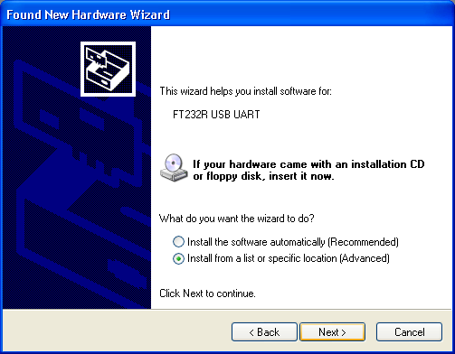
- Click on NO, not this time, Then after NEXT
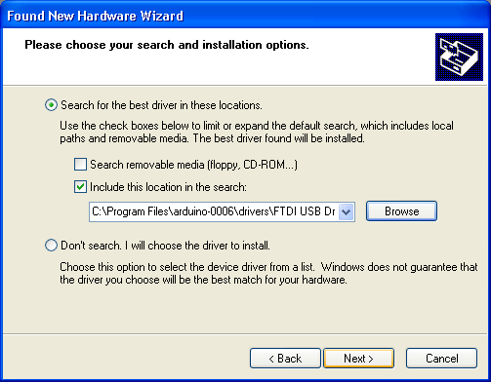
- Another Window opens – select Install from a list specific location and NEXT
- Select “include this location in the search” and then click Browse option available in it
- Now it will Automatically check the USB driver and the software is installed click Finish
.
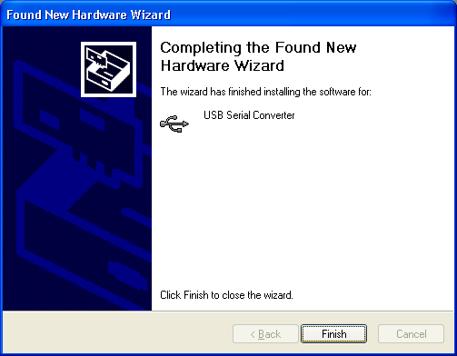

- Now click Finish, the Software will be downloaded.
- Now click on the Arduino IDE icon present on your Desktop. A window will appear like this.
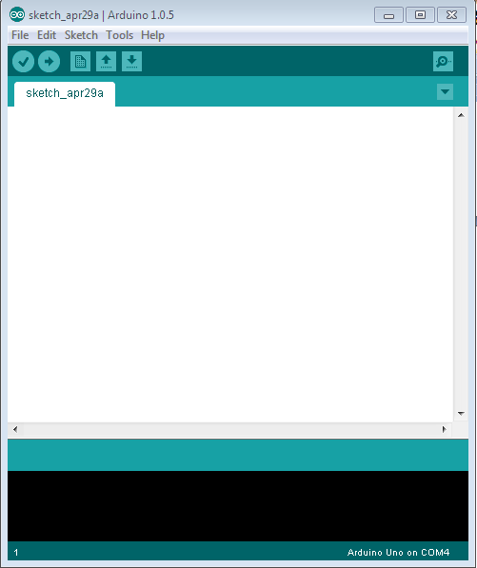
- For any sample programs, select FILE option Examples.

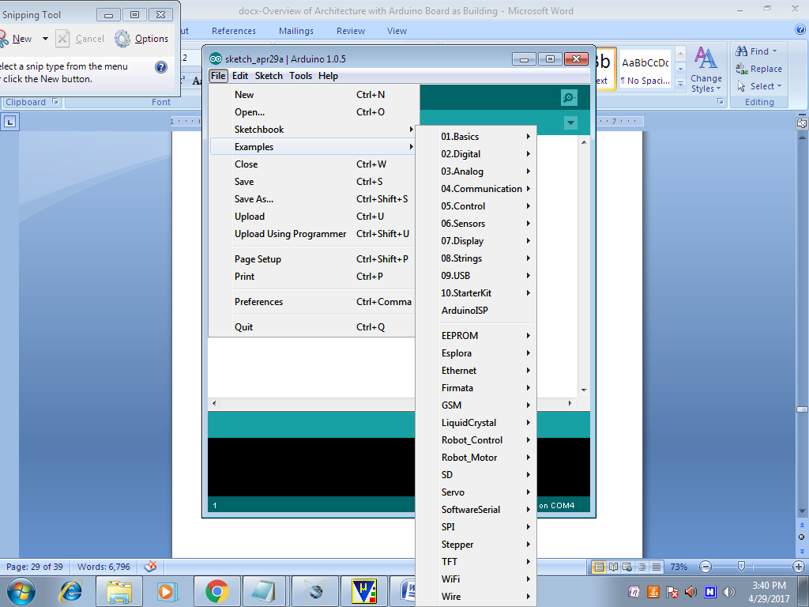
- After Entering the Sample Code in the file, it would look like this

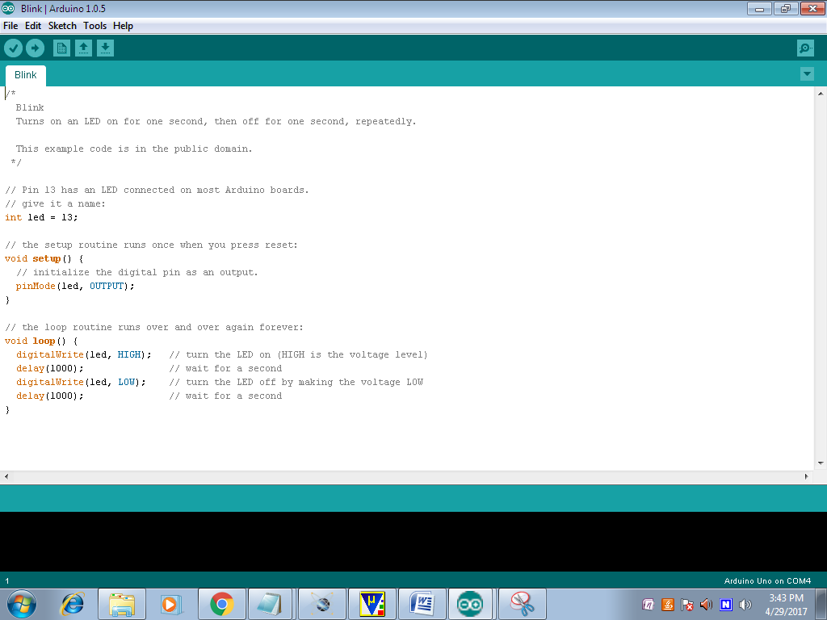
- Before Connecting we have to select which Board is used by the user, Basically UNO. By selecting TOOLSàBoardàARDUINO UNO

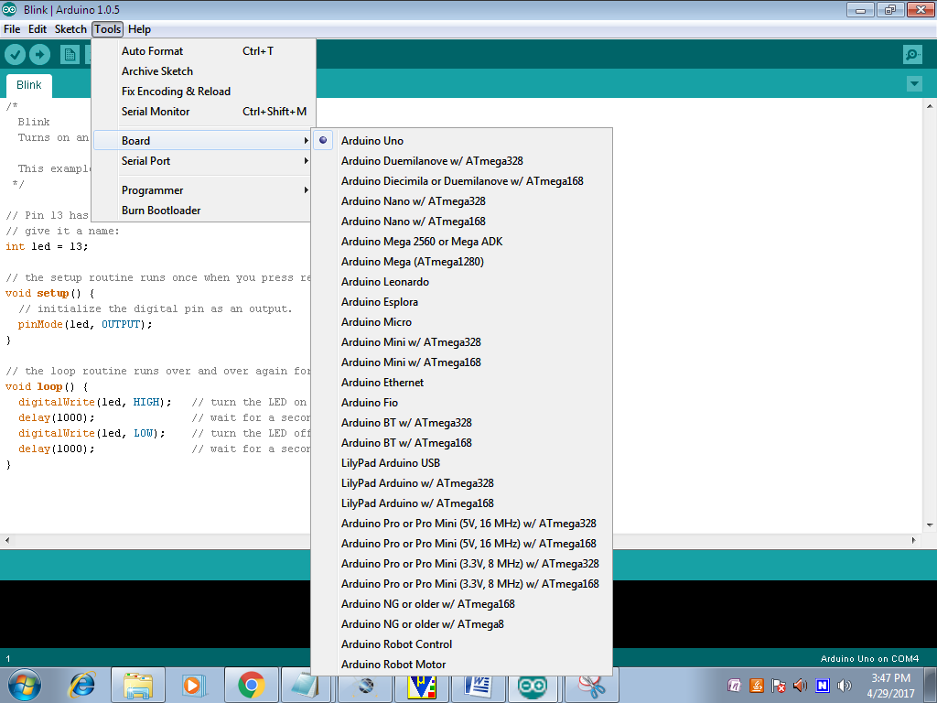
- Now to dump the in the board Connect the Arduino to the PC through the USB port available in it. Like this TOOLS à ERIAL PORT à COMM4, COMM8 etc;

- To verify the written Program select COMPILE option available in the software ($√$).
- Now Connect the Board and select the COMM port and then UPLOAD the file in ARDUINO(à)
- To OPEN the Previous ARDUINO FILE selects $(↑)$ option.
- To enter new files select NEW option.
- To Save the Existing File, Click on the$(↓)$.
- To Send the Data Through Serial Monitor, Click on the (Ǫ).

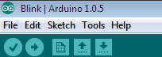

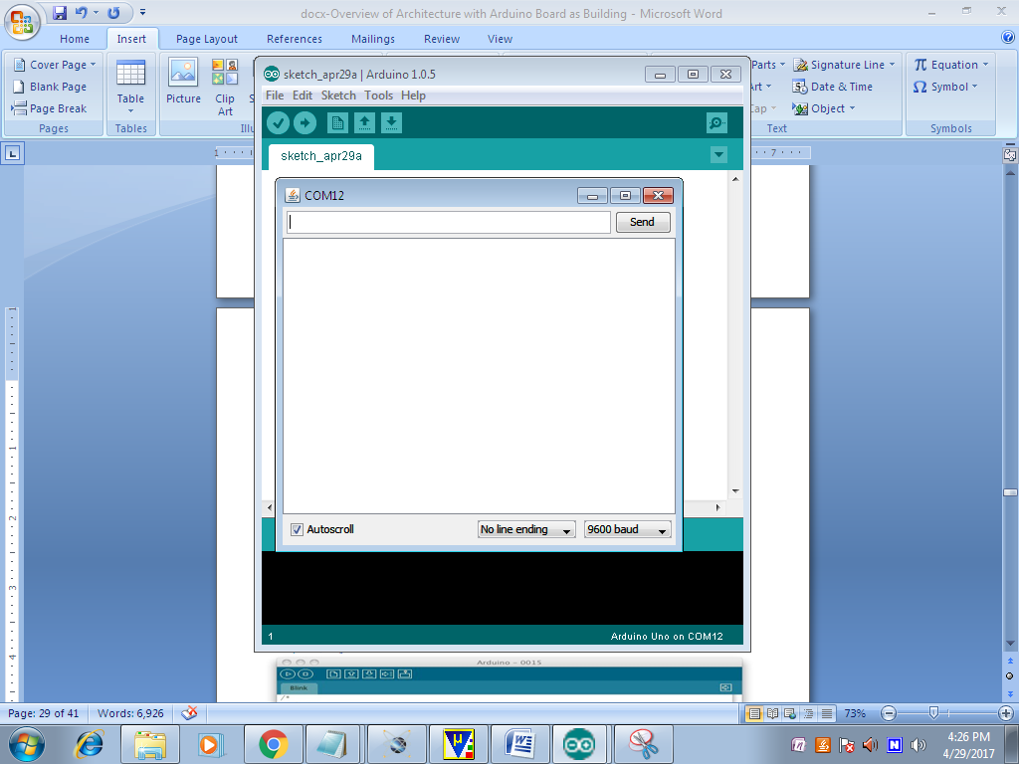

- Here we can see the Serial Data.

3.3.1 ESP32 CODE:-
#include <Wire.h>
#include <LiquidCrystal_I2C.h>
LiquidCrystal_I2C lcd(0x27, 16, 2);
// GSM Serial
HardwareSerial gsm(2); // Use UART2

// Parent numbers
String parentNumbers[] = {
"+918688934364",
"+917675903223",
"+918309199892"
};

// Buzzer pin
const int buzzerPin = 13;

void setup() {

Serial.begin(9600); // Python communication
gsm.begin(9600, SERIAL_8N1, 16, 17); // RX=16 TX=17 for GSM

pinMode(buzzerPin, OUTPUT);
digitalWrite(buzzerPin, LOW);

lcd.init();
lcd.backlight();

lcd.setCursor(0,0);
lcd.print("Attendance");
lcd.setCursor(0,1);
lcd.print("System Ready");
delay(2000);
lcd.clear();
}

void loop() {

if (Serial.available()) {

String data = Serial.readStringUntil('\n');
data.trim();

int firstComma = data.indexOf(',');
int secondComma = data.indexOf(',', firstComma + 1);
int thirdComma = data.indexOf(',', secondComma + 1);

if (firstComma == -1 || secondComma == -1 || thirdComma == -1)
return;

String status = data.substring(0, firstComma);
String idStr = data.substring(firstComma + 1, secondComma);
String name = data.substring(secondComma + 1, thirdComma);
String period = data.substring(thirdComma + 1);

int id = idStr.toInt();

lcd.clear();

if (status == "PRESENT") {

lcd.setCursor(0,0);
lcd.print(name);
lcd.setCursor(0,1);
lcd.print("Present");
delay(2000);
lcd.clear();
}

else if (status == "ABSENT") {

lcd.setCursor(0,0);
lcd.print(name);
lcd.setCursor(0,1);
lcd.print("Absent");
delay(2000);

if (id > 0 && id <= sizeof(parentNumbers)/sizeof(parentNumbers[0])) {
sendSMS(parentNumbers[id - 1], name, period);

// ===== Buzzer ON for 2 seconds =====
digitalWrite(buzzerPin, HIGH);
lcd.clear();
lcd.setCursor(0,0);
lcd.print("Message Sent");
delay(2000);
digitalWrite(buzzerPin, LOW); // Buzzer OFF

lcd.clear();
}
}
}
}

void sendSMS(String number, String name, String period) {

gsm.println("AT+CMGF=1");
delay(1000);

gsm.print("AT+CMGS=\"");
gsm.print(number);
gsm.println("\"");
delay(1000);

gsm.print("Your child ");
gsm.print(name);
gsm.print(" is ABSENT for period ");
gsm.print(period);
gsm.println(".");

gsm.write(26); // CTRL+Z
delay(4000);
}
3.3.2 Advantages (One-word):
- Accuracy
- Automation
- Security
- Efficiency
- Scalability
- Reliability
3.3.3 Applications:
- Education
- Colleges
- Schools
- Examinations
- Offices
- Institutions

CHAPTER – 4
RESULT

Accurate Attendance Tracking: Automated attendance marking with face recognition
Real-time Updates: Attendance data sent to server/cloud instantly
Proxy Prevention: Face recognition prevents fake attendance
Efficient: Saves time compared to manual attendance systems
Low Cost: ESP32 makes it a budget-friendly solution
Possible Outcomes: Attendance logs stored in a database, Notifications sent to parents/students via SMS/email, Data analytics for attendance trends
Challenges Lighting conditions affecting face detection, Need for sufficient dataset of faces for training
4.1 STUDENTS ATTENDANCE SHEET:-
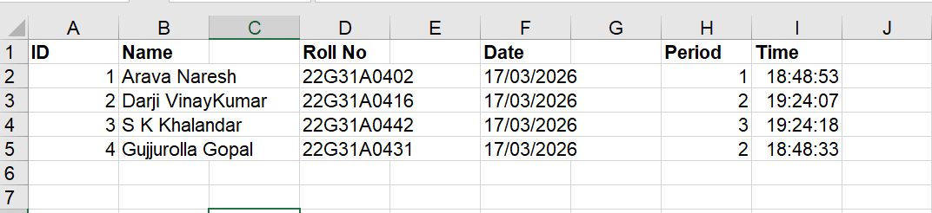

4.2 STIDENTS CAPTURED PHOTOS: -





CHAPTER – 5
CONCLUSION
AND
FUTURE SCOPE

Chapter -05
Conclusion And Future Scope
5.1 CONCLUSION:
The Face Detection-Based Attendance System using ESP32 successfully demonstrates an automated and secure approach to attendance management. By integrating real-time face recognition with embedded system control, the proposed prototype eliminates manual attendance procedures and minimizes human error. The use of a USB web camera and Python-based facial recognition ensures accurate identification of registered individuals, while the ESP32 microcontroller efficiently manages system operations and displays attendance information on an I2C LCD.
Security and reliability are further enhanced through the inclusion of a buzzer alert for unregistered detections and a GSM module for remote notification of attendance records to administrators. The system thereby prevents proxy attendance and provides real-time monitoring capabilities. Powered by a stable 12V supply and secure hardware integration, the prototype offers a cost-effective, scalable, and practical solution for modern institutions such as schools, offices, and workplaces.
5.2 Future Scope
Integration with IoT: Connect to cloud platforms (AWS, Azure) for real-time data analytics
AI Enhancements: Improve face recognition accuracy with machine learning models
Mobile App: Develop an app for notifications, attendance tracking, and reports
Biometric Fusion: Combine face recognition with other biometrics (fingerprint, voice)
Edge Computing: Process data on ESP32 itself for offline functionality
Scalability: Deploy in schools, offices, and public places for automated attendance
Potential Applications- Smart schools and universities
Corporate offices for secure attendance
Events and conferences for attendee tracking

5.3 References:
- R. Sharma, P. Verma, “Automated Attendance System Using Face Recognition,” International Journal of Computer Applications, 2021.
- A. Kumar, S. Reddy, “Smart Attendance Monitoring System Using IoT and Face Detection,” IEEE Conference on IoT Systems, 2022.
- Viola, P., Jones, M., “Rapid Object Detection using a Boosted Cascade of Simple Features,” IEEE CVPR, 2001.
- Espressif Systems, “ESP32 Technical Reference Manual,” 2023.
- Gonzalez, R. C., Woods, R. E., “Digital Image Processing,” Pearson Education, 4th Edition.
- OpenCV Documentation, “Face Recognition and Image Processing,” OpenCV.org.
- M. Turk and A. Pentland, “Eigenfaces for Recognition,” Journal of Cognitive Neuroscience, vol. 3, no. 1, pp. 71–86, 1991.
- S. Z. Li and A. K. Jain, Handbook of Face Recognition, 2nd ed., Springer, 2011.
- A. Rosebrock, Practical Python and OpenCV: Case Studies, PyImageSearch Publications, 2016.
- R. Szeliski, Computer Vision: Algorithms and Applications, Springer, 2010.
- D. Lowe, “Distinctive Image Features from Scale-Invariant Keypoints,” International Journal of Computer Vision, vol. 60, no. 2, pp. 91–110, 2004.
- SIMCom Wireless Solutions, SIM800 Series AT Command Manual, SIMCom Ltd., 2020.
- Python Software Foundation, “Python Language Reference Manual,” Available: https://www.python.org
- Arduino, “Wire Library for I2C Communication,” Arduino Official Documentation, 2022.
- J. Redmon and A. Farhadi, “YOLOv3: An Incremental Improvement,” arXiv preprint arXiv:1804.02767, 2018.
- H. Rowley, S. Baluja, and T. Kanade, “Neural Network-Based Face Detection,” IEEE Transactions on Pattern Analysis and Machine Intelligence, vol. 20, no. 1, pp. 23–38, 1998.

